Flood Anticipation and Risk Management
30 October 2026
Takeaways
- A holistically integrated short-term, mid-and-long-term flood risk management plans, from anticipation of crises, inclusive and coordinated crises management, to recovery plans in institutionalized manners.
- Effective and responsible use of AI tools would help manage the flood risks, provide real-time data to users regarding evacuation plans and shelter capacity, while combatting fake news during crises.
- The current sewage system is not suitable to meet the flood challenges. Modernization of the sewage system is needed.
- Inclusive and timely evacuation plans are crucial to save lives. According to the 2021 experience, most people dead are over 60 due to the difficulties in evacuation of care home residents.
- In the mid-to-long term, public awareness raising via education and communication, pre-and post-crises are crucial for greater public preparedness.

Introduction

In July 2021, after weeks of persistent rain, an extreme storm released roughly two months’ worth of rainfall over western Germany and eastern Belgium within a few days. The Vesdre and Meuse rivers overflowed their banks and the Ahr valley was devastated. Entire streets were submerged, roads were washed away, and more than two hundred people lost their lives, with total damage estimated in the tens of billions of euros. The floods struck the cross-border region spanning the Belgian provinces of Liège and Limburg, Dutch Limburg, and the German Region Aachen, where rivers do not stop at national lines and neither does the risk they carry.

Five years on, the region faces a renewed early warning of heavy rainfall over the Meuse and Vesdre catchments, and decision-makers are asking a single question: after everything that has been done since 2021, would the region be better prepared if the same flood returned tomorrow? This question cannot yet be answered with confidence. Although the 2021 flood extent is known from satellite mapping and data on population, buildings, and recovery measures are publicly available, this information remains fragmented across datasets, institutions, and national borders. What is missing is a single, integrated assessment that links what was flooded, what has changed since, and what would happen if the event recurred.

Our tool can assess the damage area, shelter (hospital, school, stadium), road, navigation system (Best direction), evacuation area, diagram for science research, 3D and 2D simulation for the flood,

What science tells us
Research RESULTS: paint a general picture of the research findings before moving on to the specifics.
IMPLICATIONS are the effects that the research could have in the future. They are a soft but persuasive approach to describe the potential consequences of particular policies.
Think of the conclusion as a mirror to your introduction: you are once again providing an overview of your argument, but this time you are underlining its strength rather than introducing it.
The whole graph of our simulation is need to put in here

Box text
(feel free to place this box anywhere in the document or remove it)
-Figure 1: Name of illustration, source [1] (there must be at least one-two data visualisations or illustrations in the document)
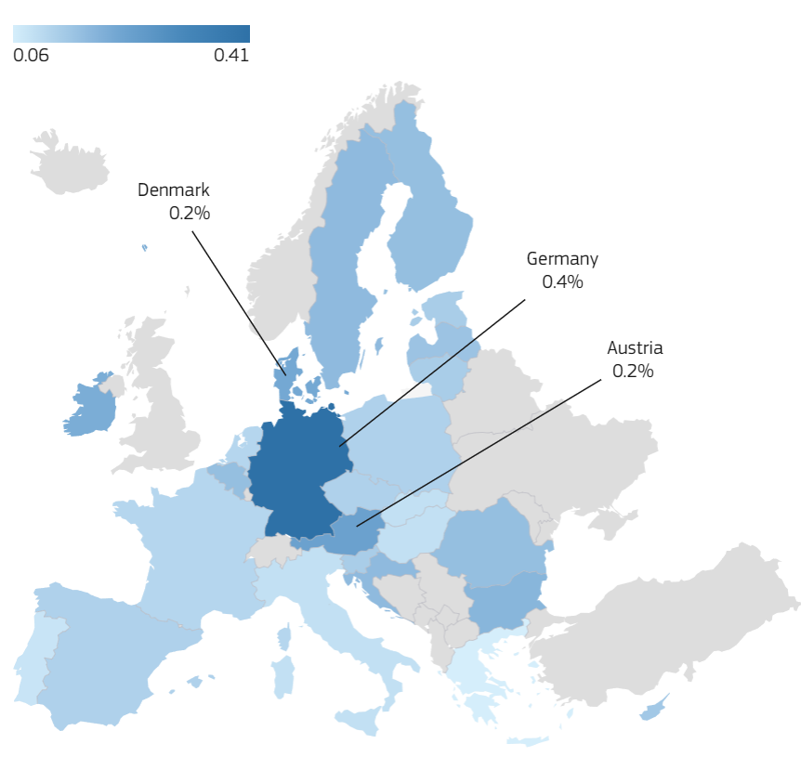
Tips:
- Avoid jargon and overly technical language
- Focus on highlighting the benefits and opportunities stemming from solving the focused problem using the presented research
- Interpret the data in a way that is accessible and clearly connected to your policy advice.
- Express ideas using active language and strong assertions.
- Explain the findings and limitations of the research.
- Express research findings in terms of how they relate to concrete realities (instead of theoretical abstractions).

Policy implications
Short-Term
Anticipation of crises
- Early alert system (identification of risks, impact areas, flood risk monitoring)
- Preparedness (protection of critical infrastructures, identification and coordination with resources/ alternative supplies to be mobilized)
- Effective and responsible use of AI tools for early detection and monitoring of risks
Coordination of responses
- Crisis Management (coordinated crisis responses led by public authorities, in partnership with private entreprises, and households)
- Risk Mitigation (integration of flood risk management into urban and rural planning, insurance policies, public finance and budget planning)
- Communication with the general public on what to do in various scenarios (avoid risky areas, stay at home, waterproof materials in front of doors)
- Inclusive Crisis Management (Help physically challenged people and old people to safe shelters through apps like Help A Friend and construction of Barrier-Free Shelters).
- Efficient and timely evacuation of care home residents can reduce death and casualty from flood. According to the 2021 experience, in North Rhine-Westphalia, people over 60 made up two thirds of the dead (Thieken et al. 2023).
- Interactive apps with most time-efficient evacuation plans for each resident where users can signal any route blockage or problems. Apps also indicate the capacity and occupation rate of each shelter.
Mid-to Long-Term
Institutionalization of crisis management
- Pre-Crisis: Relocation based on new zoning system
- Post-Crisis: Recovery plans
- Awareness raising through education and communication
- If budget allows, modernization of the (old) sewage system
Impact: lives saved, money saved

References
[1] Greenall, J. S., Cornu, L., Maigrot, A.-L., De La Torre, M. P., & Briefer, E. F., (2022), Age, empathy, familiarity, domestication and call features enhance human perception of animal emotion expressions, Royal Society Open Science 9, 221138 doi: 10.1098/rsos.221138.
[2] GreenState, (2024), What is Modular Farming? – Agriculture 2.0, https://greenstate.ch/blog-posts/modular-farmingagriculture- 2-0/.
[3] Guan, Y., Yan, J., Shan, Y., Zhou, Y., Hang, Y., Li, R., Liu, Y., Liu, B., Nie, Q., Bruckner, B., Feng, K., & Hubacek, K., (2023), Burden of the global energy price crisis on households, Nature Energy 8, 304–316 doi: 10.1038/s41560-023- 01209-8.
[4] Guerra, S., (2020), Brexit: The EU27’s Momentary Lapse of Unity, Political Insight 11, 34–36 doi: 10.1177/2041905820933374.
[5] Thieken, A., Zenker, M.-L., & Bubeck, P. (2023). Flood-related fatalities during the flood of July 2021 in North Rhine-Westphalia, Germany: what can be learnt for future flood risk management? . Journal of Coastal and Riverine Flood Risk , 2. https://doi.org/10.59490/jcrfr.2023.0005

Authors: Team 3

Drivers of the 2021 flood and scenario design
Research on the July 2021 event shows that its severity resulted not from rainfall alone but from several interacting factors, which we used as the adjustable parameters of our simulation.
First, rainfall intensity: attribution analysis found that anthropogenic climate change has already increased the intensity of the maximum 1-day summer rainfall event by 3–19%, and that the likelihood of such an event today, compared with a 1.2 °C cooler climate, has increased by a factor of 1.2–9 (Tradowsky et al., 2023). The flood response to rainfall is also non-linear: hydrological modelling of the Ahr showed that under a +2 K scenario, an 18% increase in areal rainfall led to a 39% increase in the flood peak (Ludwig et al., 2023).
Second, antecedent soil moisture: simulations indicate that the upper soil in the Ahr, Erft and Kyll catchments buffered about one third to half of the precipitation, whereas the Vesdre catchment, starting from higher soil saturation, had lower buffering capacity, so more precipitation was transferred into discharge (Goergen et al., 2025).
Third, debris and infrastructure: the heavy rain also triggered slope failures, mobilised tree trunks that clogged bridges, and routed debris across the landscape; in the Ahr valley, 62 out of 75 bridges were destroyed (Dietze et al., 2022). Finally, the spatial location of rainfall matters: a counterfactual study that systematically shifted the event’s precipitation fields in space concluded that the outcome could have been considerably worse (NHESS, 2025). Attribution of the heavy rainfall events leading to severe flooding in Western Europe during July 2021 +7
Based on these findings, we reproduced the 2021 flood as a baseline and then varied [rainfall intensity / soil moisture / bridge clogging / land use — 실제 사용한 요인] to test how exposure and shelter coverage change under each scenario. [Results of the factor-based simulation here.]

References
- Dietze, M. et al. (2022). More than heavy rain turning into fast-flowing water – a landscape perspective on the 2021 Eifel floods. Nat. Hazards Earth Syst. Sci., 22, 1845–1856. https://doi.org/10.5194/nhess-22-1845-2022
- Goergen, K., Belleflamme, A., Hammoudeh, S., Vanderborght, J., & Kollet, S. (2025). The July 2021 flood event in the Eifel-Ardennes mountains as simulated by the high-resolution integrated hydrologic model ParFlow. Frontiers in Water. https://doi.org/10.3389/frwa.2025.1571704
- Ludwig, P. et al. (2023). A multi-disciplinary analysis of the exceptional flood event of July 2021 in central Europe – Part 2: Historical context and relation to climate change. Nat. Hazards Earth Syst. Sci., 23, 1287–1311. https://doi.org/10.5194/nhess-23-1287-2023
- Tradowsky, J. S. et al. (2023). Attribution of the heavy rainfall events leading to severe flooding in Western Europe during July 2021. Climatic Change, 176, 90. https://doi.org/10.1007/s10584-023-03502-7
- It could have been much worse: spatial counterfactuals of the July 2021 flood in the Ahr Valley, Germany (2025). Nat. Hazards Earth Syst. Sci., 25, 2007. https://doi.org/10.5194/nhess-25-2007-2025 (Need to check)

- Table 1. Flood drivers of the July 2021 event and literature-based ranges for scenario design
Factor | 2021 baseline | Literature-based change | Effect on flood | Source
Rainfall amount / intensity | >150 mm over 2 days across a large area; up to 150 mm within 15–18 h in parts of the Ahr catchment | Climate change has already increased max 1-day summer rainfall intensity by 3–19%; +11–18% event rainfall totals under +2 °C | Non-linear response: +18% areal rainfall → +39% flood peak at Altenahr (+2 K scenario) | Tradowsky et al. (2023); Ludwig et al. (2023)
Rainfall location (spatial shift) | Observed 2021 rainfall footprint | Shift of the rainfall field by 15–20 km | Peak flow at Altenahr +32%, up to +160% at tributaries; flood volume >25% larger. Worst case: 1311 vs 1004 m³/s | Vorogushyn et al. (2025); Voit & Heistermann (2024)
Antecedent soil moisture | Upper soil in Ahr, Erft and Kyll buffered ~1/3–1/2 of rainfall | Vary initial saturation (no fixed % reported) | Vesdre had higher initial saturation → lower buffering → more rainfall converted to discharge | Goergen et al. (2025)
Debris & bridge clogging | 62 of 75 bridges destroyed in the Ahr valley | No blockage / partial / full blockage scenarios | Water levels >2 m above the 1804 flood, likely due to bridge clogging, backwater and denser settlement | Dietze et al. (2022); Mohr et al. (2023)
Peak discharge (calibration target) | Ahr (Altenahr): 750–1100 m³/s vs. previous record 236 m³/s (2016). Downstream peaks: Ahr ~990, Vesdre ~600, Geul ~90 m³/s |  | Eupen (Vesdre) peak >4× the 100-year return flow | Vorogushyn et al. (2025); Thewissen (2022); ULiège HECE (2026)
References
Dietze, M., Bell, R., Ozturk, U., Cook, K. L., Andermann, C., Beer, A. R., et al. (2022). More than heavy rain turning into fast-flowing water – a landscape perspective on the 2021 Eifel floods. Natural Hazards and Earth System Sciences, 22, 1845–1856. https://doi.org/10.5194/nhess-22-1845-2022
Goergen, K., Belleflamme, A., Hammoudeh, S., Vanderborght, J., & Kollet, S. (2025). The July 2021 flood event in the Eifel-Ardennes mountains as simulated by the high-resolution integrated hydrologic model ParFlow. Frontiers in Water. https://doi.org/10.3389/frwa.2025.1571704
Journée, M., Goudenhoofdt, E., Vannitsem, S., & Delobbe, L. (2023). Quantitative rainfall analysis of the 2021 mid-July flood event in Belgium. Hydrology and Earth System Sciences, 27, 3169–3189. https://doi.org/10.5194/hess-27-3169-2023
Ludwig, P., Ehmele, F., Franca, M. J., Mohr, S., Caldas-Alvarez, A., et al. (2023). A multi-disciplinary analysis of the exceptional flood event of July 2021 in central Europe – Part 2: Historical context and relation to climate change. Natural Hazards and Earth System Sciences, 23, 1287–1311. https://doi.org/10.5194/nhess-23-1287-2023
Thewissen, A. (2022). Flood event of July 2021: How extreme were the floods in the Ahr, Vesdre and Geul catchments? MSc thesis, TU Delft.
Tradowsky, J. S., Philip, S. Y., Kreienkamp, F., Kew, S. F., et al. (2023). Attribution of the heavy rainfall events leading to severe flooding in Western Europe during July 2021. Climatic Change, 176, 90. https://doi.org/10.1007/s10584-023-03502-7
Voit, P., & Heistermann, M. (2024). A downward-counterfactual analysis of flash floods in Germany. Natural Hazards and Earth System Sciences, 24, 2147. https://doi.org/10.5194/nhess-24-2147-2024
Vorogushyn, S., Han, L., Apel, H., Nguyen, V. D., Guse, B., Guan, X., Rakovec, O., et al. (2025). It could have been much worse: spatial counterfactuals of the July 2021 flood in the Ahr Valley, Germany. Natural Hazards and Earth System Sciences, 25, 2007. https://doi.org/10.5194/nhess-25-2007-2025

